# **Exercise 2 - Puppet**

# **Discover environments:**

Run:

sudo puppet config print environment

cd $(sudo puppet config print environmentpath)

pwd

ls –l production/

ls –l production/modules/

cd /home/

sudo puppet module list

sudo puppet module install puppetlabs/ntp

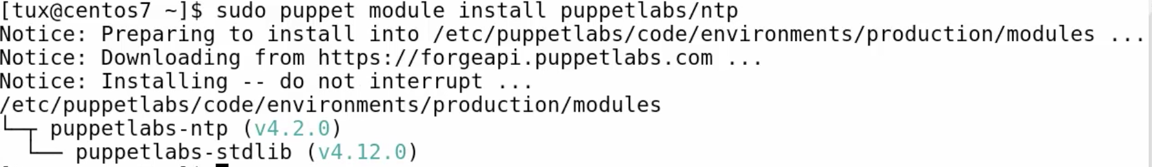

sudo puppet module list

sudo puppet module uninstall puppetlabs/ntp

now lets install with specific directory

sudo puppet module install puppetlabs/ntp –I /etc/puppetlabs/code/modules

now run :

sudo puppet module list

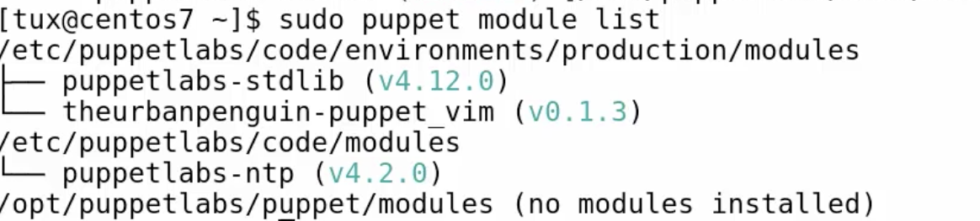

now its common module

lets stdlib a common module

first uninstall the module

then install as you learned before

now run :

sudo puppet module list

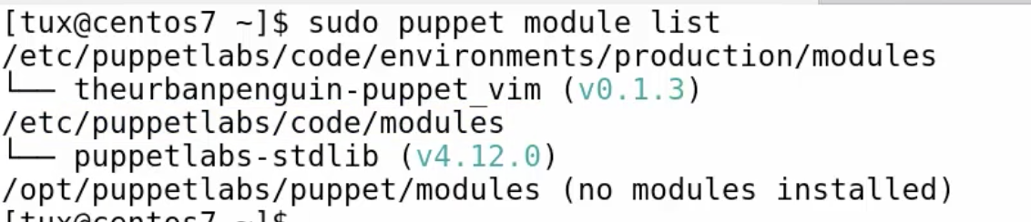

make sure you have it like in the image

now lets create a environment

sudo mkidr –p /etc/puppetlabs/code/environments/dev/{modules,manifests}

now lets install ntp module into dev environment

make sure the module is uninstalled first

now run :

sudo puppet module install puppetlabs/ntp –environment dev

now run :

sudo puppet module list –environment dev

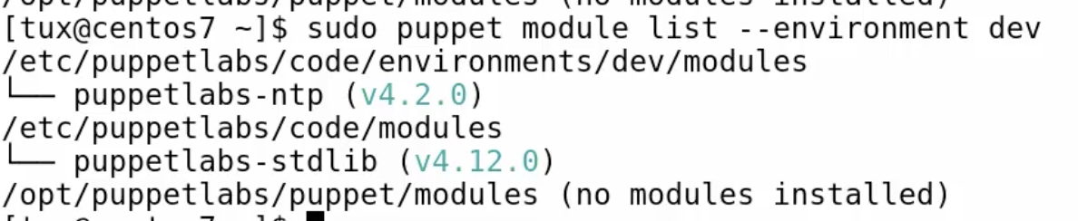

now lets check which default environment we are in :

sudo puppet config print environment



now lets change that

cat /etc/puppetlabs/puppet/puppet.conf

sudo puppet config set environment dev

now run this again :

cat /etc/puppetlabs/puppet/puppet.conf

sudo puppet config print environment



now run :

sudo puppet module list

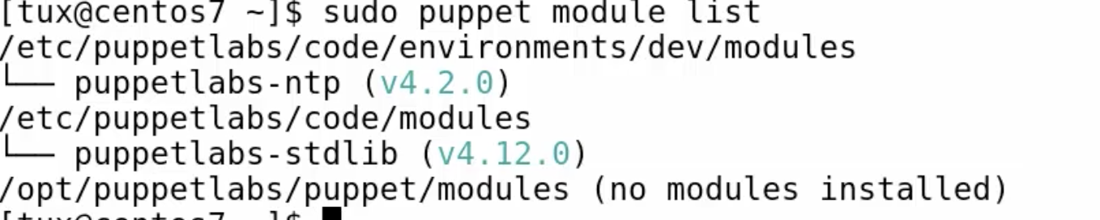

lets create a simple module:

cd /etc/puppetlabs/code/environments/production/modules

also make sure your default environment is back to production and not dev

sudo mkdir –p motd/{manifests,files.examples}

sudo vim motd/manifests/init.pp

class motd {

file { ‘/etc/motd’:

ensure => ‘present’,

content => file(‘motd/message’),

}

}

save and exit

now lets create the message file

sudo vim motd/files/message

Welcome to my server

Please be nice

Save and exit

Lets run this

sudo puppet apply –e ‘include motd’

now

cat /etc/motd

sudo puppet module list

now generate a meta data to your module with interview

after that

run:

sudo puppet module list

now lets do some classes with step1

cd /etc/puppetlabs/code/environments/production/modules

sudo mkdir –p ntp/{manifests,files,examples}

cp ~/ntpfinal.pp ntp/manifests/init.pp

sudo vim ntp/manifests/init.pp

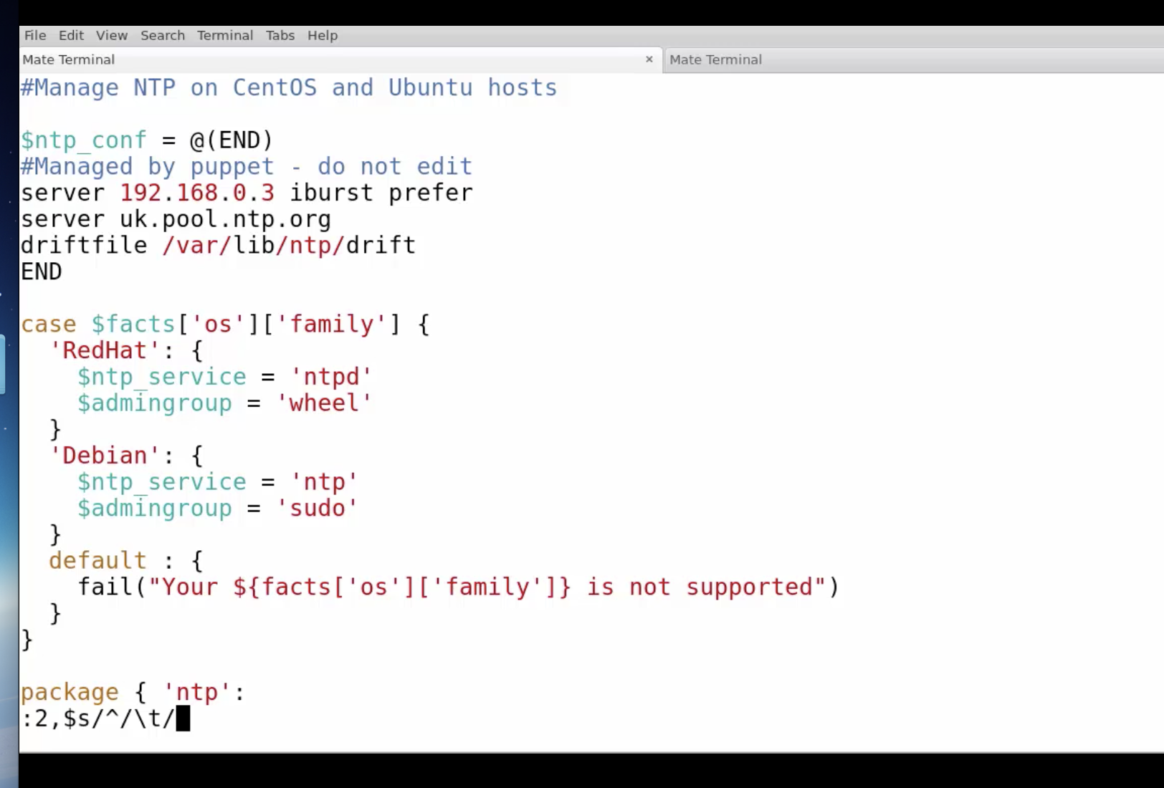

hit enter

add }

go to top of the line

class ntp {

save and exit

tree ntp

now lets create a file named ntp.conf

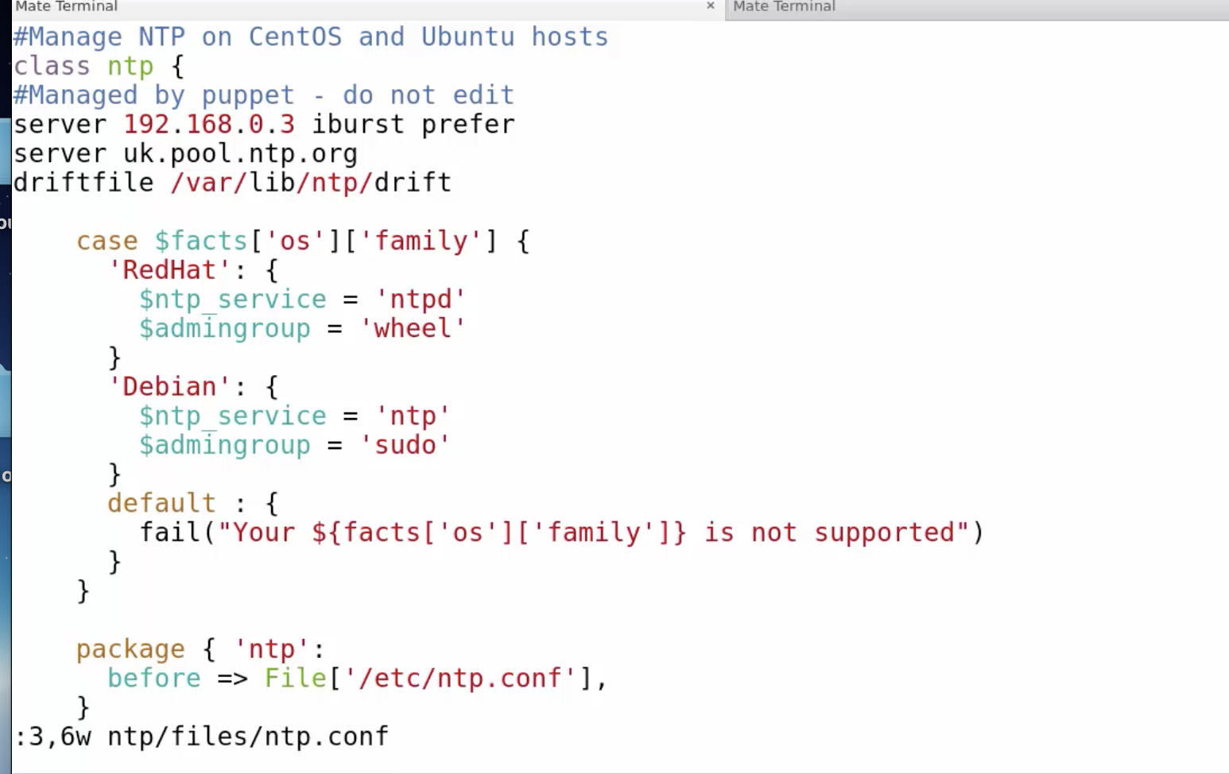

now continue like in the demo

make sure you take the file configuration ntp

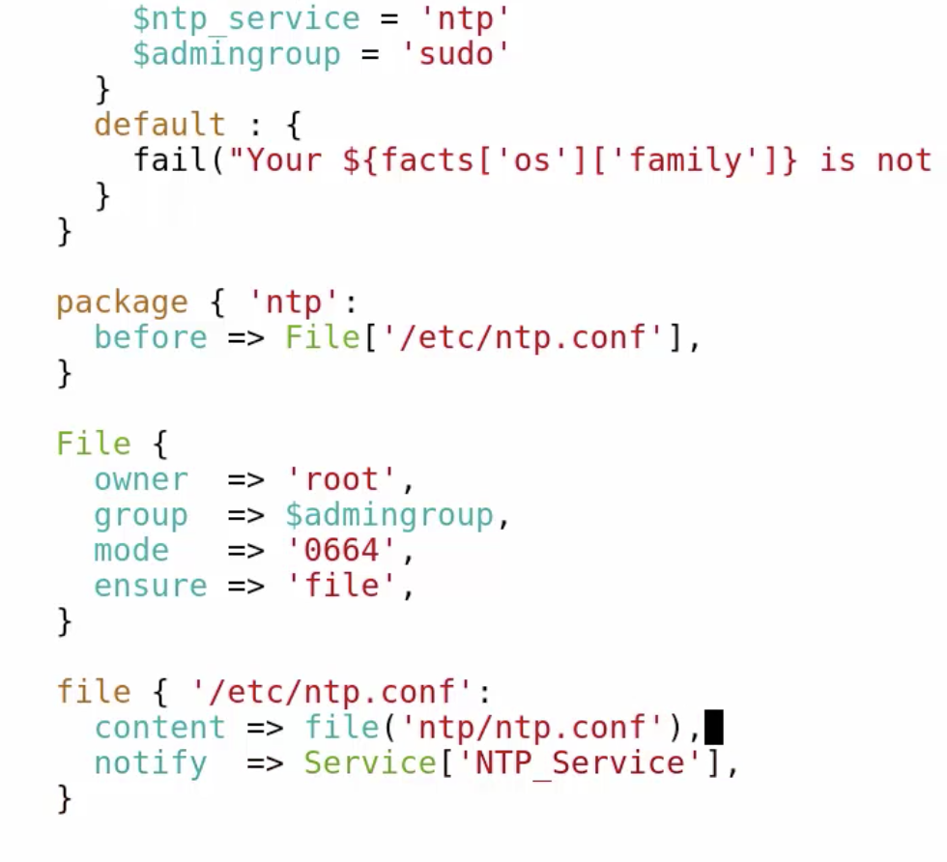

now lets run this:

sudo puppet apply –e ‘include ntp’

sudo rm /etc/ntp.conf

sudo puppet apply –e ‘include ntp’

now lets do sub-classes – breakdown the manifests

vim the init.pp

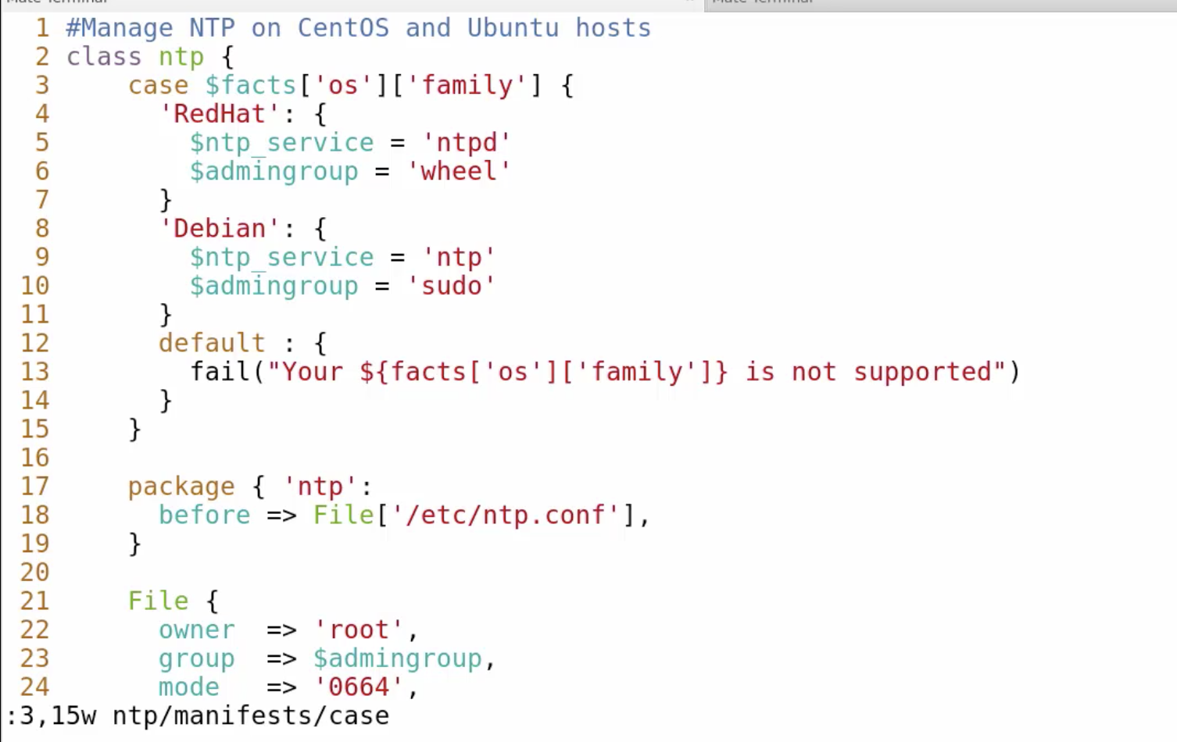

now lets take out the file also

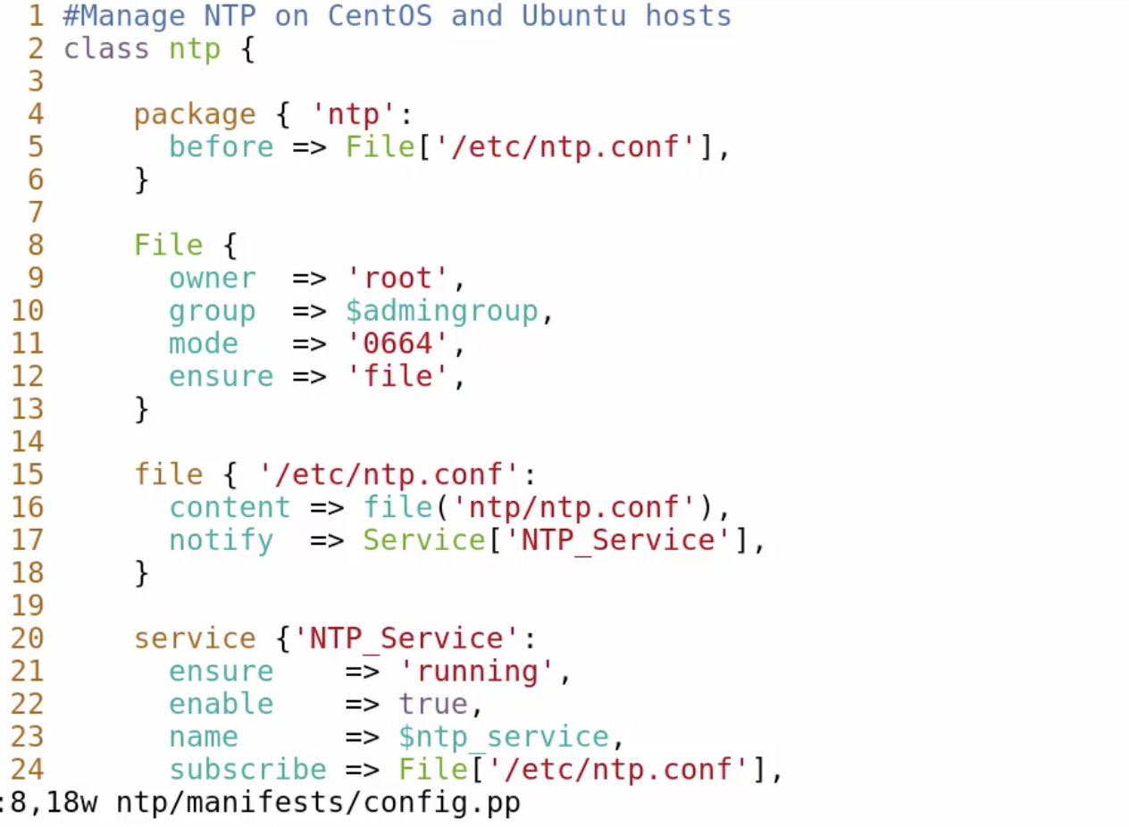

now lets take out the service also

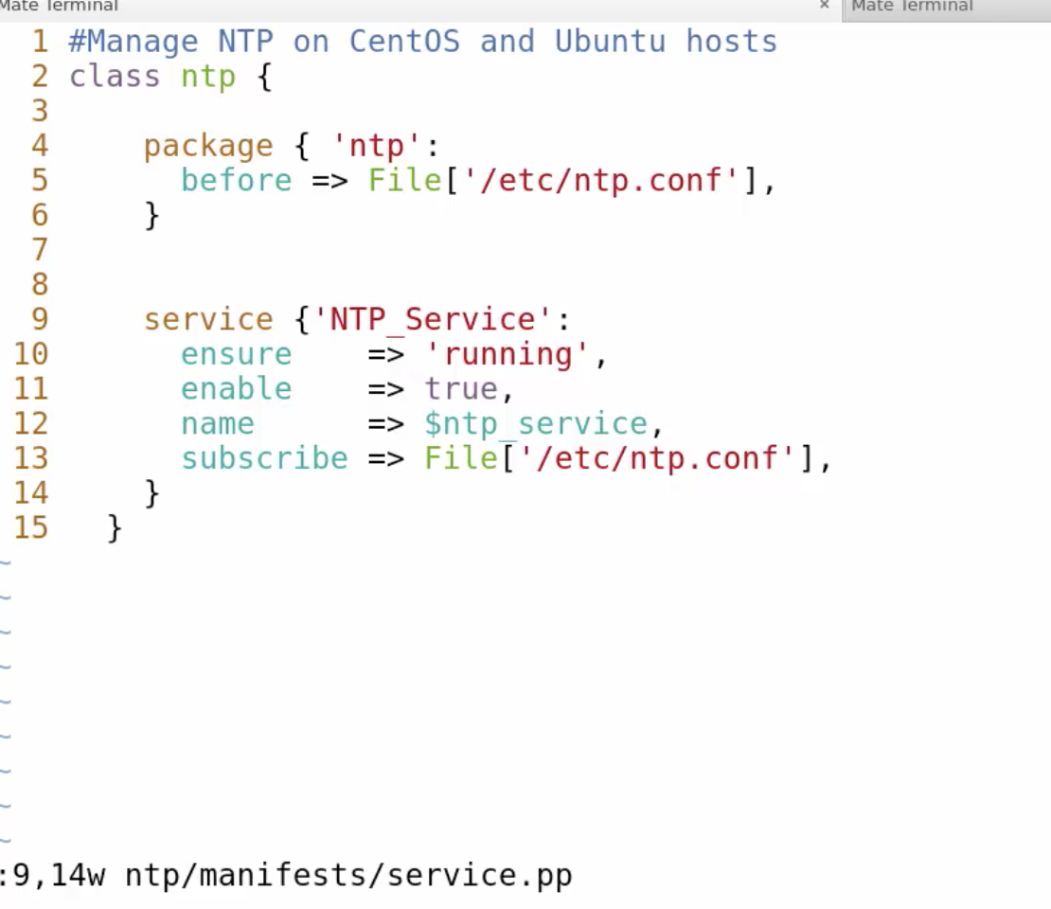

now lets change what left to this:

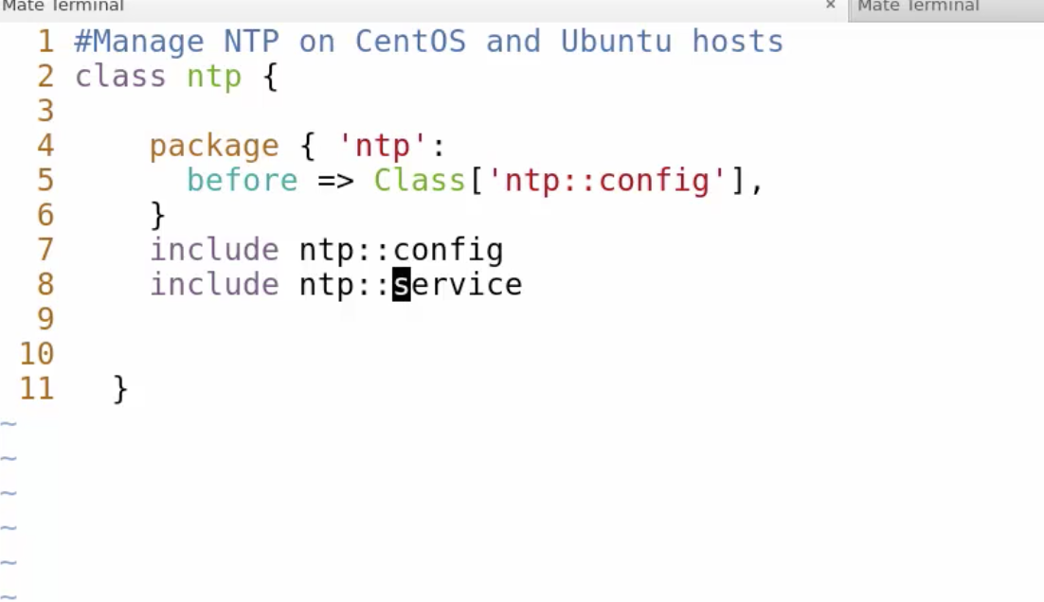

now lets make a sub class for config.pp

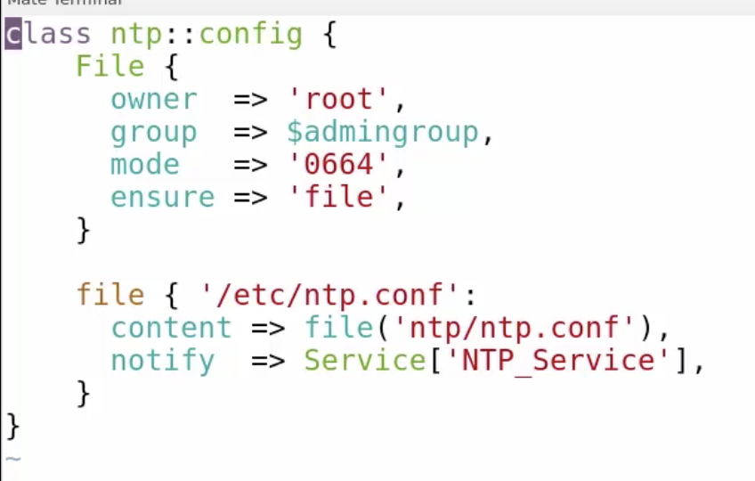

now lets read in the case statement from before

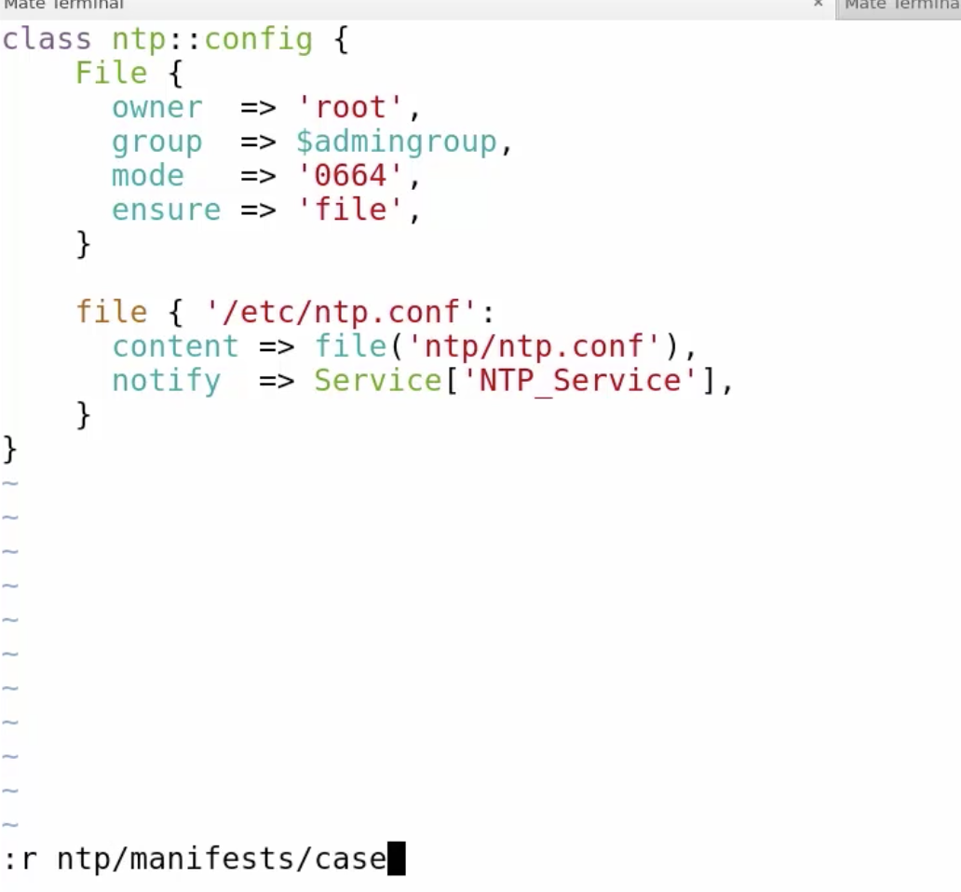

make it like that

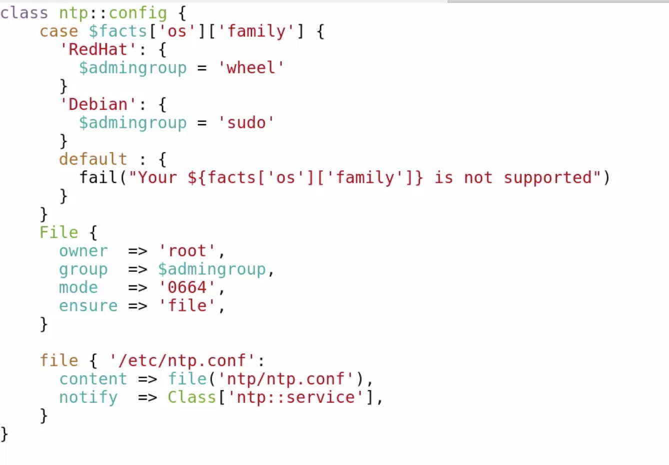

now lets edit service.pp

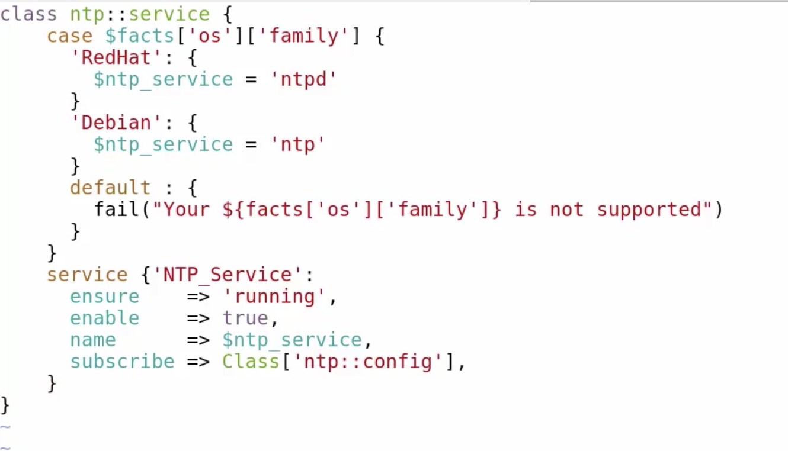

now review all the files before running

and then run :

sudo puppet apply –e ‘include ntp’

sudo rm /etc/ntp.conf

run the puppet apply again with the ntp class

Lets work with Parameterized Classes:

Cd /etc/puppetlabs/code/environmnets/production/modules

ls

sudo vim motd/manifests/init.pp

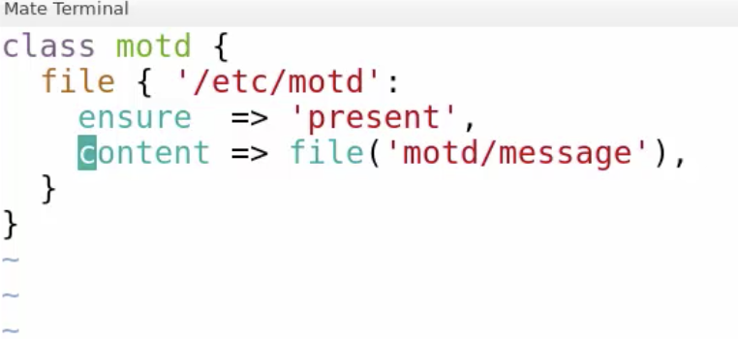

now lets change to that :

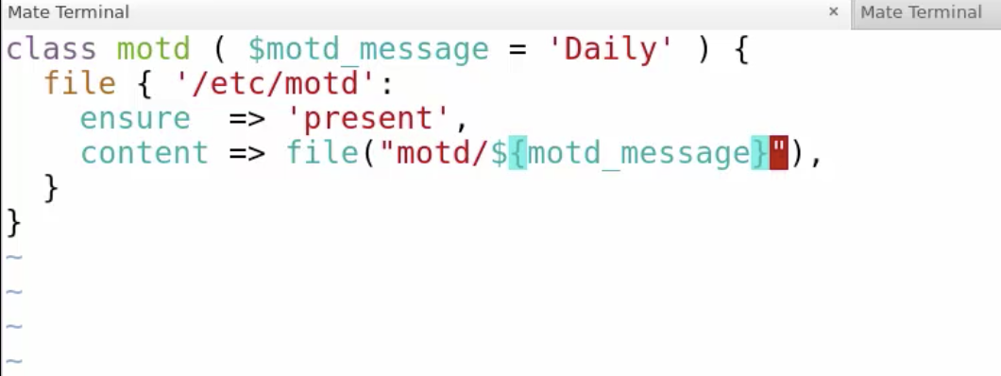

now lets create some files

sudo vim motd/files/Daily

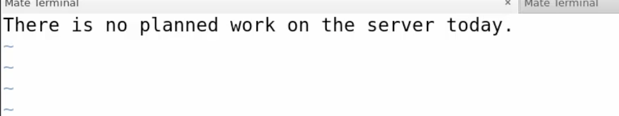

sudo vim motd/files/Weekly

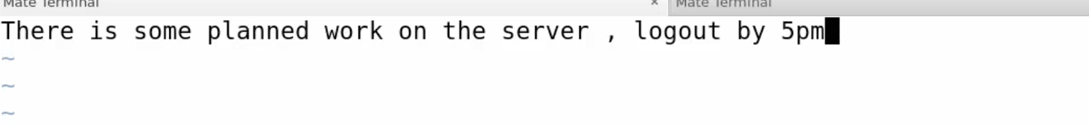

lets declare the classes with parameter:

run:

tree motd

sudo vim motd/examples/init.pp

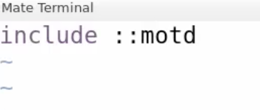

sudo puppet apply motd/examples/init.pp

cat /etc/motd

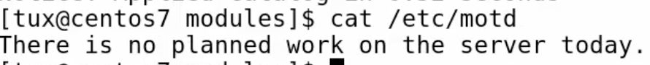

sudo vim motd/examples/init.pp

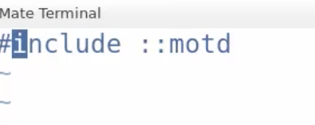

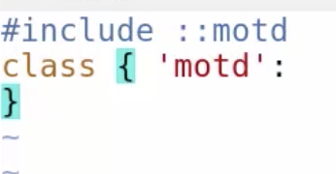

sudo puppet apply motd/examples/init.pp

sudo vim motd/examples/init.pp

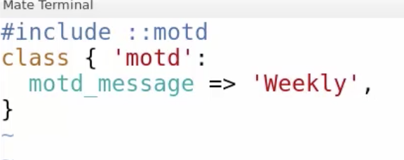

cat /etc/motd



Validating Input :

sudo vim motd/examples/init.pp

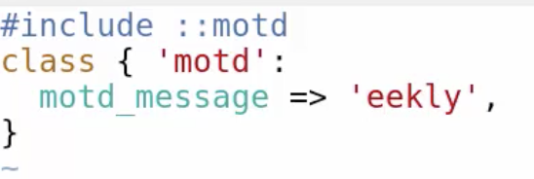

misspelled Weekly

sudo puppet apply motd/examples/init.pp

Sudo vim motd/manifests/init.pp

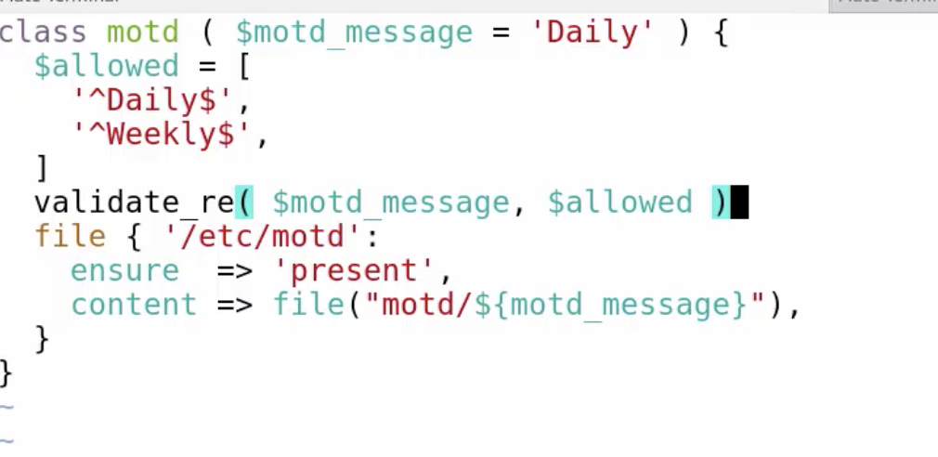

sudo vim motd/examples/init.pp

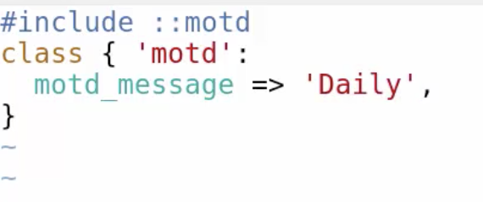

sudo puppet apply motd/examples/init.pp

cd /ntp/files

ls

cat ntp.conf

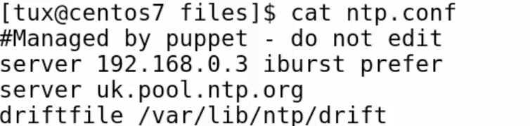

sudo cp ntp.conf london

sudo cp ntp.conf paris

now lets change paris file

sudo vim paris

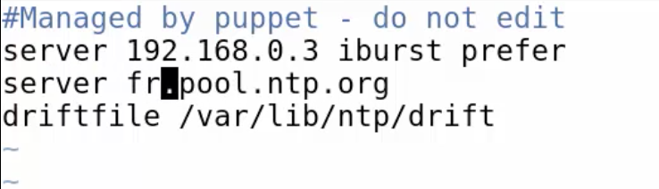

sudo cp ntp.conf nyc

sudo vim nyc

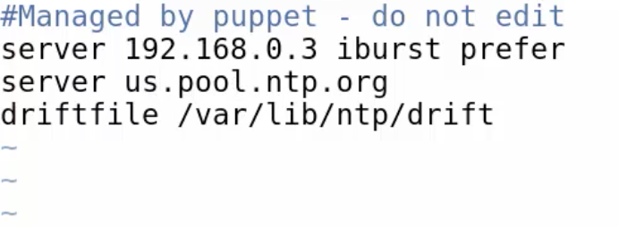

cd ../manifests/

ls

sudo vim config.pp

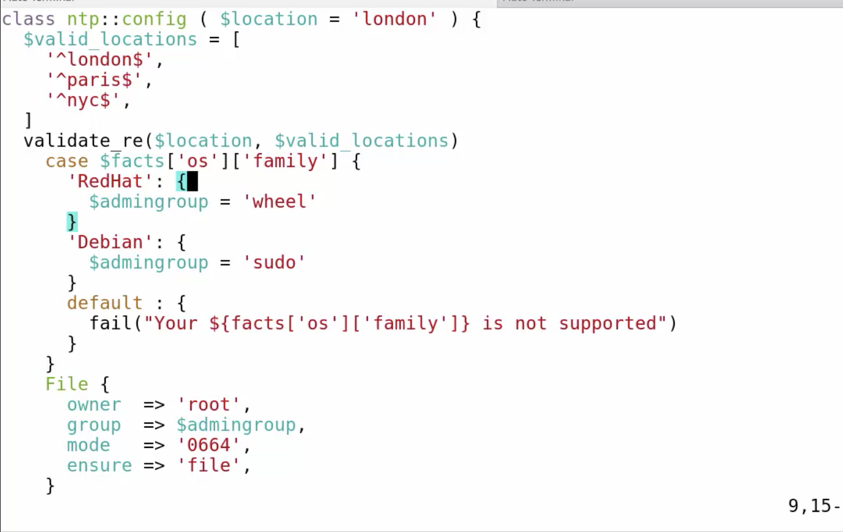

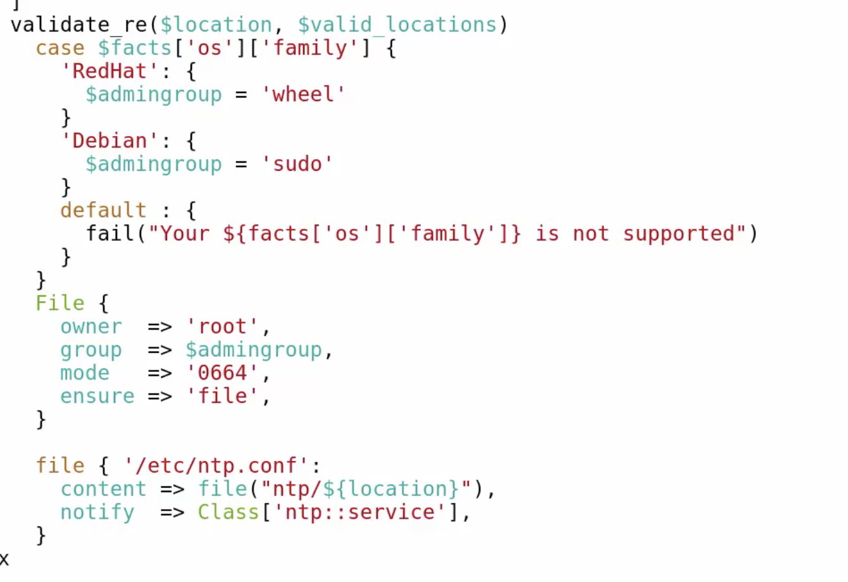

sudo vim init.pp

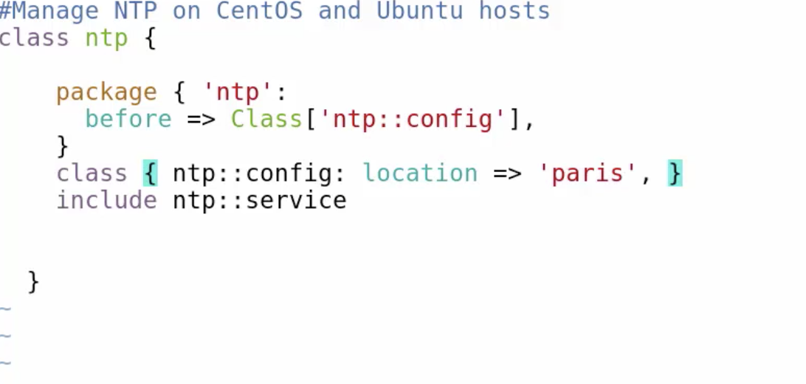

sudo puppet apply –e ‘include ntp’

cat /etc/ntp.conf

Cd /etc/puppetlabs/code/environments/production/modules

cat ntp/manifests/config.pp

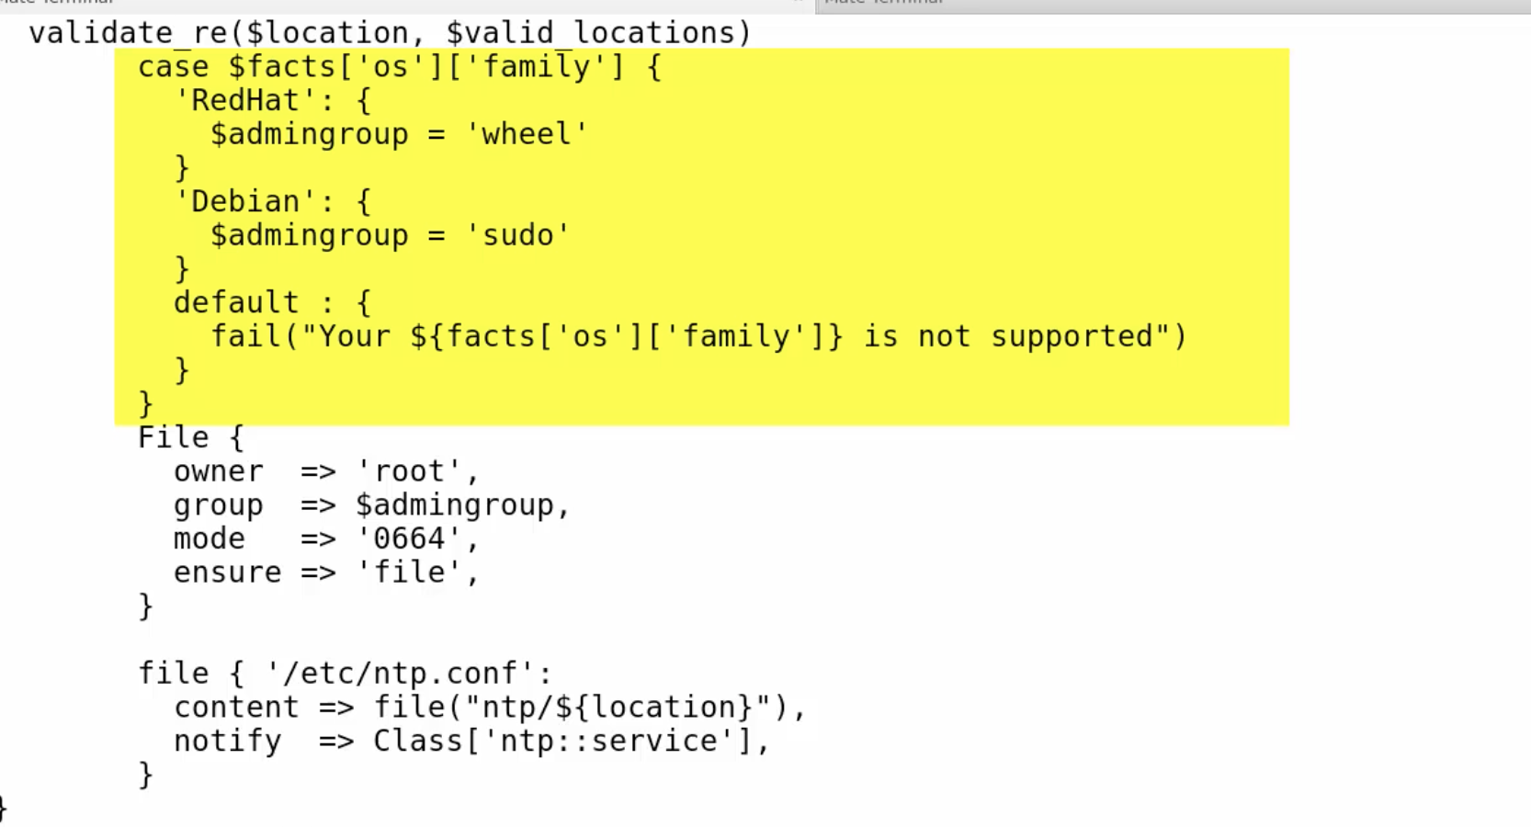

cat ntp/manifests/service.pp

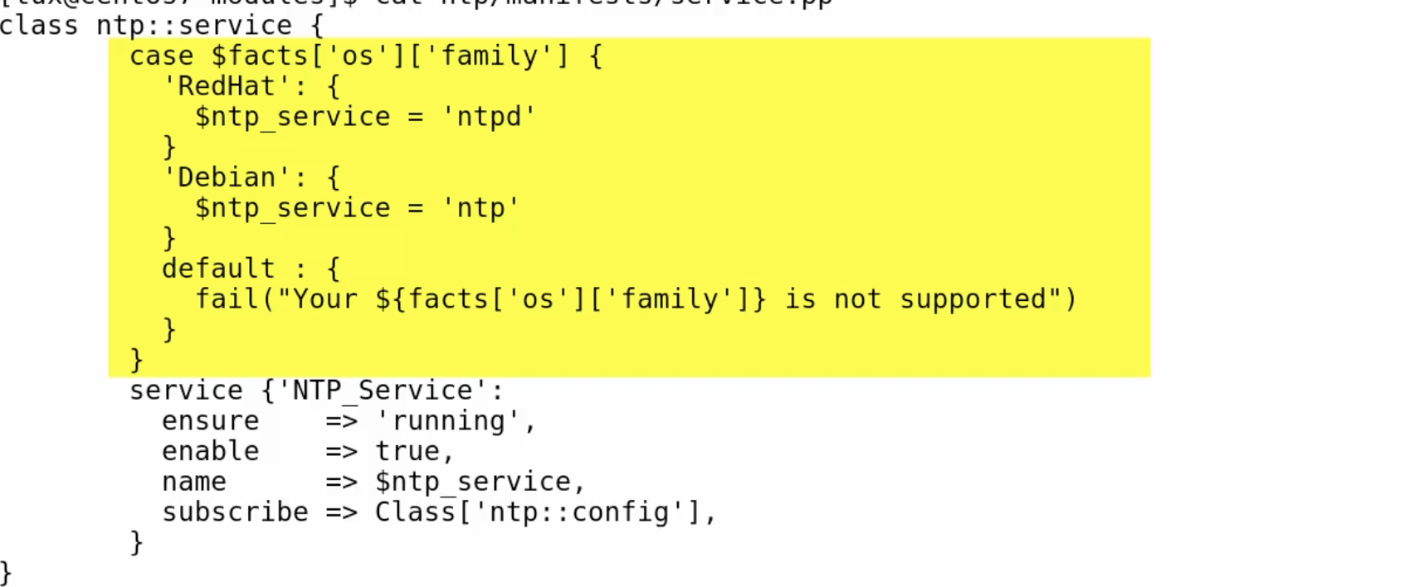

cat ntp/manifests/case

sudo mv ntp/manifests/case ntp/manifests/params.pp

sudo vim ntp/manifests/params.pp

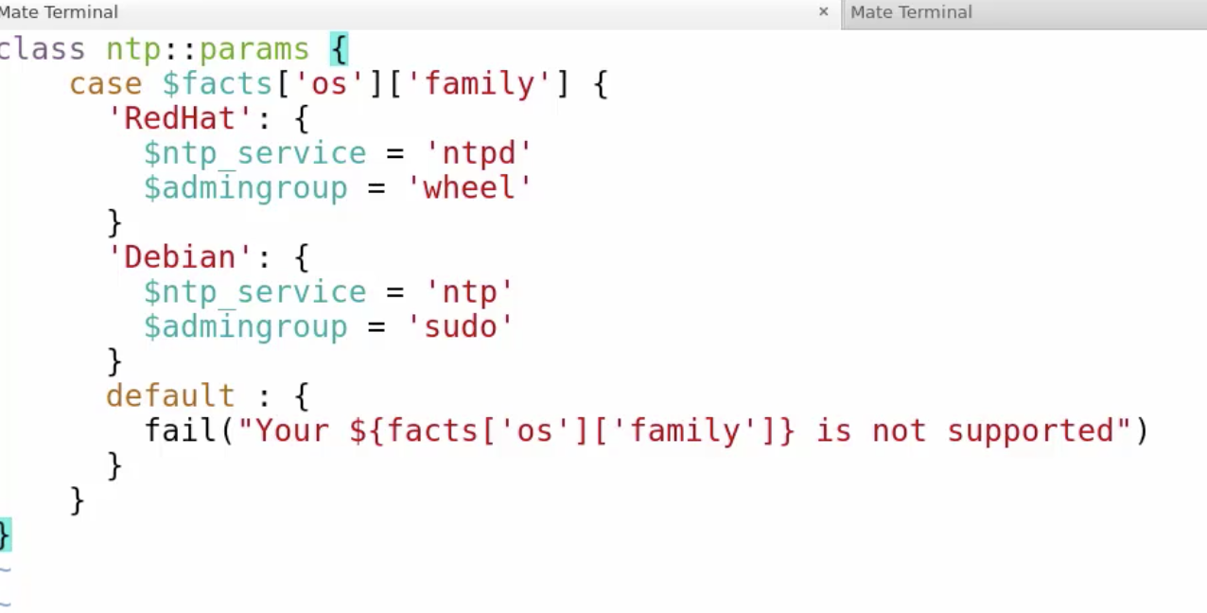

sudo puppet parser validate ntp/manifests/params.pp

sudo vim ntp/manifests/config.pp

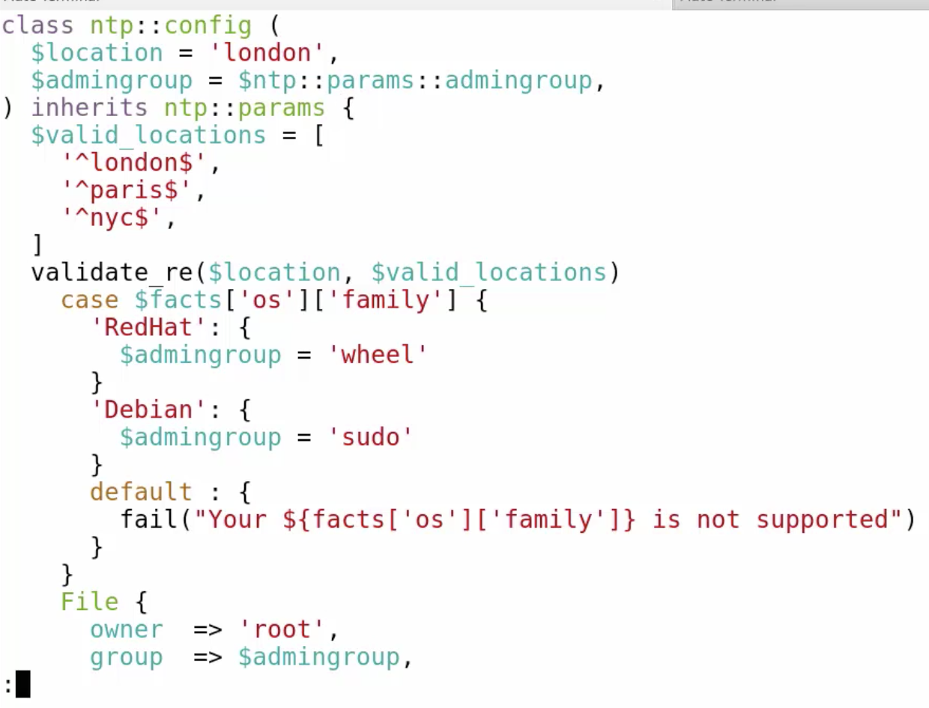

sudo vim ntp/manifests/service.pp

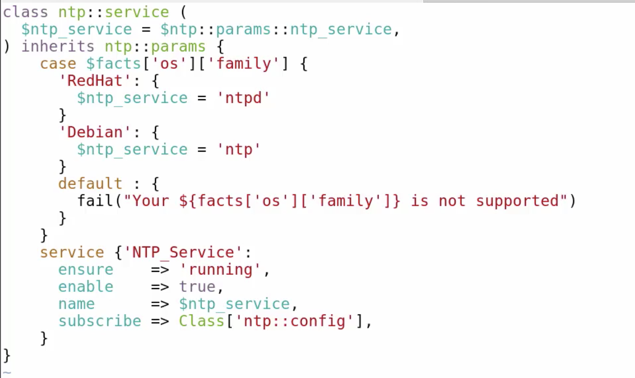

lets do line count on each one

sudo wc –l ntp/manifests/service.pp

sudo wc –l ntp/manifests/config.pp

now remove the case lines from service.pp

also remove the same line from config.pp

sudo puppt apply –e ‘include ntp’

sudo rm /etc/ntp.conf

sudo puppt apply –e ‘include ntp’

develop your own custom resource:

cd /etc/puppetlabs/code/environments/production/modules

sudo puppet desctibe –list

sudo puppet desctibe –list | grep myfile

sudo mkdir –p motd/lib/puppet/{type,provider}

tree motd

sudo vim motd/lib/puppet/type/myfile.rb

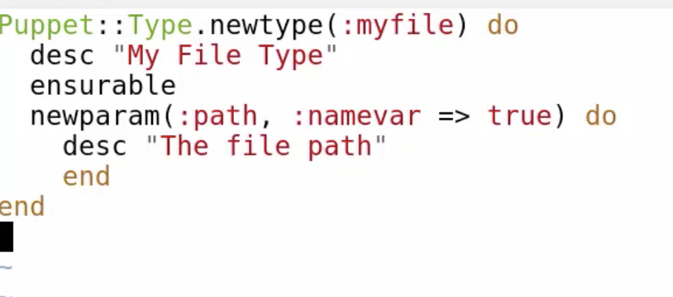

save and exit

sudo puppet desctibe –list | grep myfile

sudo puppet describe myfile

lets use a provider for our resource:

tree motd

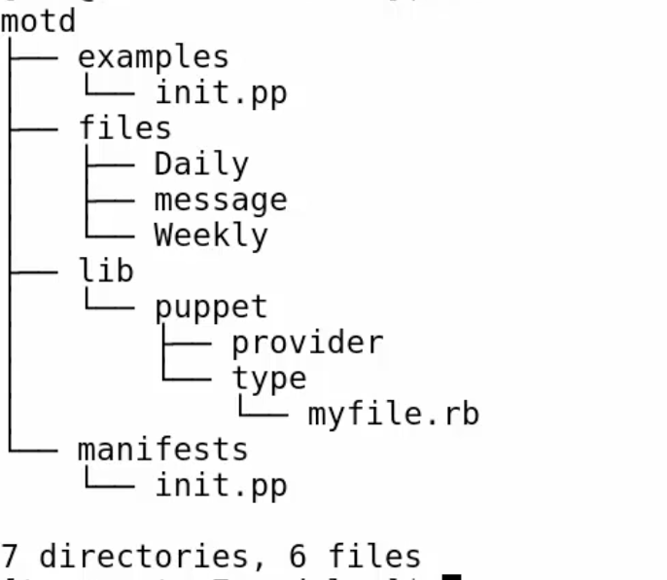

sudo mkdir motd/lib/puppet/provider/myfile

sudo vim !$/posix.rb

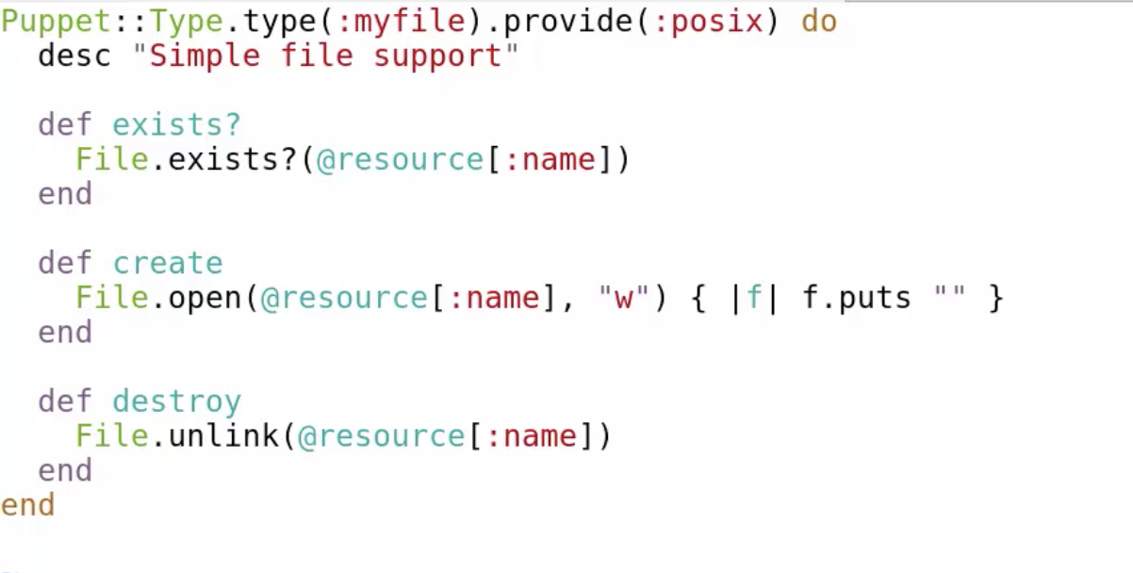

sudo puppet describe myfile

sudo vim motd/manifests/init.pp

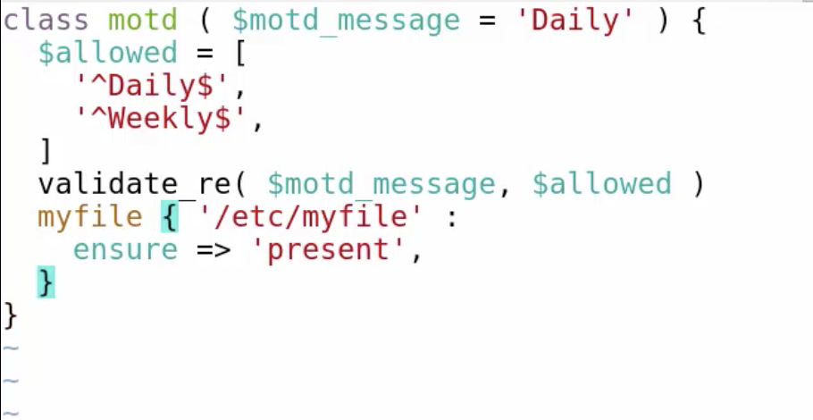

sudo puppet apply –e ‘include motd’

sudo vim motd/manifests/init.pp

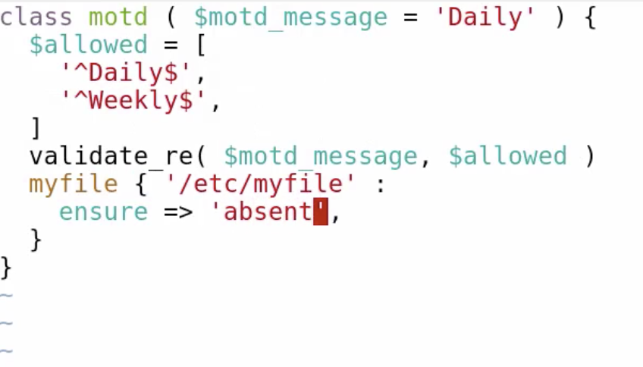

sudo puppet apply –e ‘include motd’

lets create an admin_file for ntp as defined type:

sudo vim ntp/manifests/admin_file.pp

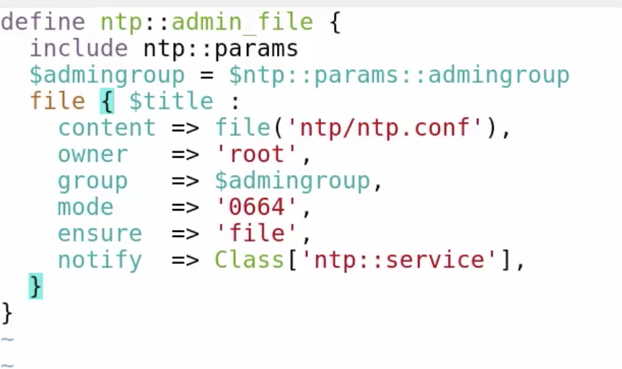

sudo vim ntp/manifests/config.pp

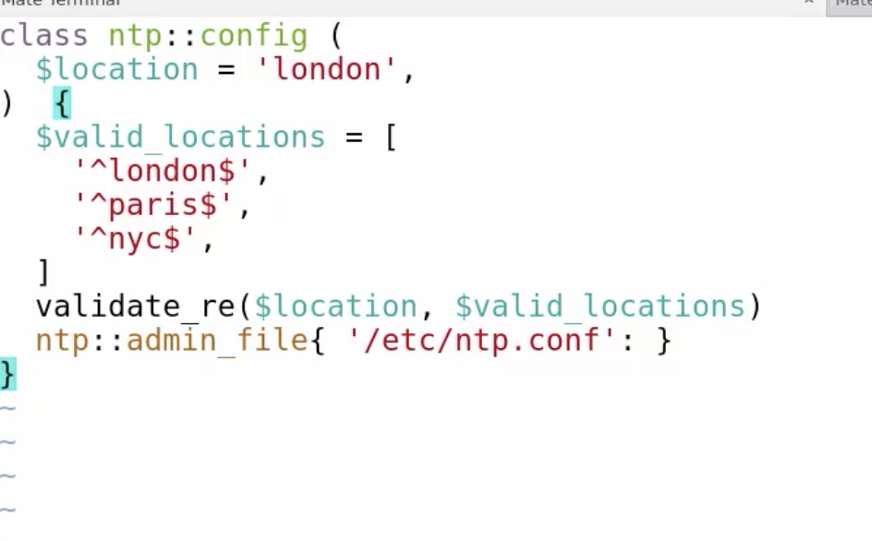

sudo puppet apply –e ‘include ntp’